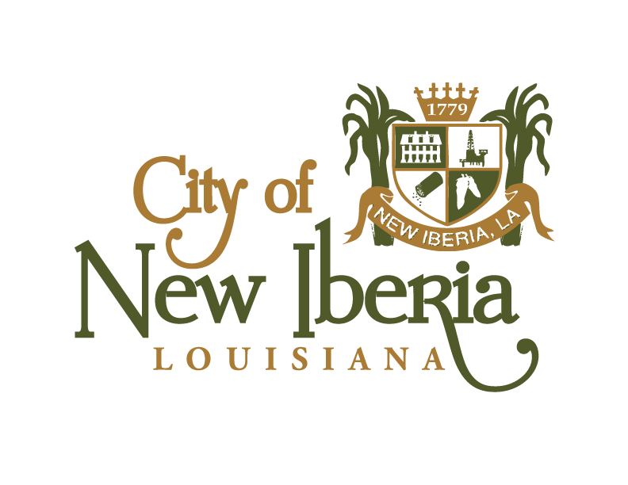
NEW IBERIA CITY COUNCIL
MEETING AGENDA
TUESDAY, SEPTEMBER 7, 2021, @ 5:30 P.M.
CITY HALL COUNCIL CHAMBERS

CALL TO ORDER
PRAYER & PLEDGE OF ALLEGIANCE: MARLON LEWIS

ROLL CALL: _____ Mayor Pro Tem Ricky Gonsoulin
______Councilmember Brooke Marcotte _____Councilmember Marlon Lewis
_____ Councilmember David Broussard _____Councilmember Deidre Ledbetter ______Councilmember Deedy Johnson-Reid _____Councilmember Dustin Suire

- PUBLIC COMMENT:

- ACCEPTANCE OF THE MINUTES:

  - Acceptance of the minutes of August 17, 2021, which will publish on Wednesday, September 8, 2021.

- PERSONS TO ADDRESS THE COUNCIL:

  - Cynthia Elmer with the American Foundation for Suicide Prevention to address the council for Suicide Awareness Week.

- PUBLIC HEARING:

  - Public Hearing for Ordinance 2021-13: An ordinance creating City of New Iberia Economic Development District No. 3 in accordance with and as authorized by Part II of Chapter 27 of Title 33 of the Louisiana Revised Statutes of 1950, as amended; defining the boundaries thereof; and providing for other matters in connection therewith.

  - Public Hearing for Ordinance 2021-14: An ordinance confirming the final form and execution of the Bond Purchase Agreement in connection with the issuance and sale of Revenue and Refunding Bonds, Series 2021 of the City of New Iberia, State of Louisiana, and providing for other matters in connection therewith.

- ADOPTION OF ORDINANCES:

- Ordinance 2021-13: An ordinance creating City of New Iberia Economic Development District No. 3 in accordance with and as authorized by Part II of Chapter 27 of Title 33 of the Louisiana Revised Statutes of 1950, as amended; defining the boundaries thereof; and providing for other matters in connection therewith.

- Ordinance 2021-14: An ordinance confirming the final form and execution of the Bond Purchase Agreement in connection with the issuance and sale of Revenue and Refunding Bonds, Series 2021 of the City of New Iberia, State of Louisiana, and providing for other matters in connection therewith.

- RESOLUTIONS:

  - Resolution 21-96: Authorizing the Mayor to sign an agreement between the City of New Iberia and Kolder, Slaven, & Company for the professional services and authorizing the Mayor to execute all contracts in connection therewith

  - Resolution 21-97: Awarding contract to Minvielle Lumber Company, Inc. for the Visitor’s Pavilion Conversion Project

  - Resolution 21-98: Awarding contract to Bulliard Construction Company, Inc. for the Kayak Launch Park Project.

  - Resolution 21-99: Endorsing the application of Cane River Pecan Company for the Restoration Tax Abatement Program.

- PLANNING AND ZONING RECCOMENDATIONS:

  - Resolution 21-100: Authorizing the City of New Iberia to prepare and submit an application to the Louisiana Department of Wildlife and Fisheries for assistance in the implementation of the construction of “Felicite’s Landing” through the Sport Fish Restoration Program, providing for necessary documentation or the need for the construction and providing for other matters in connection therewith.

  - Resolution 21-101: A resolution in support of a grant application to the Louisiana Department of Wildlife and Fisheries through the Sport Fish Restoration Program for assistance in implementation of the construction of Boat Slips for Transient Motorboats:” A Boating Access Project” for Civic Center Circle (West).

- FINANCE REPORTS:

  - Kevin Zerangue to present monthly budget reports for November 1, 2020 through June 30, 2021 and November 1, 2020 through July 31, 2021.

- COUNCIL REMARKS:

- ANNOUNCEMENTS:

- The next regularly scheduled city council meeting will be held on Tuesday, September 21, 2021.

- Reminder to council and citizens to participate in the MS4 Storm Water Survey at www.cityofnewiberia.com under Public Works section.

- City of New Iberia currently has adjudicated properties available for sale at CivicSource.com. To initiate the auction process on one or more properties, the investor must place a deposit of $850 on each property, which starts the prerequisite legal research and notification process that is required before the auction takes place. The pre-sale process takes approximately 120 days to complete. If the current property owner pays all delinquent taxes and fees during the pre-sale period, the depositor is refunded the deposit and the sale is halted. Visit CivicSource.com to learn more.

- ADJOURN:

