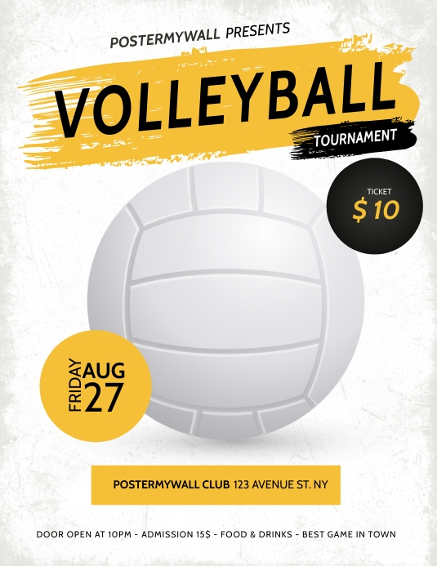

**Ages 9 - 13**

**Fee**

**Locations: CITY PARK & WEST END PARK**

**APRIL**

**19th thru 23rd**

**5pm – 7pm**

**For more information call (337) 369-2337**

**FUNDEMENTAL VOLLEYBALL AT ITS BEST**

**CLINIC**

**$35**

**NIRD PRESENTS**