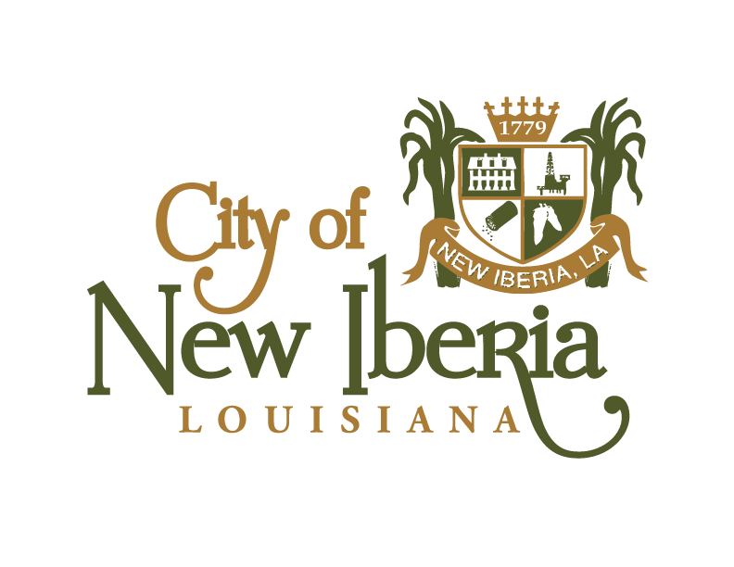
NEW IBERIA CITY COUNCIL
MEETING AGENDA
TUESDAY, JULY 20, 2021, @ 5:30 P.M.
CITY HALL COUNCIL CHAMBERS

*AMENDED*

CALL TO ORDER
PRAYER & PLEDGE OF ALLEGIANCE: DUSTIN SUIRE

ROLL CALL: _____ Mayor Pro Tem Ricky Gonsoulin
______Councilmember Brooke Marcotte _____Councilmember Marlon Lewis
_____ Councilmember David Broussard _____Councilmember Deidre Ledbetter ______Councilmember Deedy Johnson-Reid _____Councilmember Dustin Suire

- PUBLIC COMMENT:

- ACCEPTANCE OF THE MINUTES:

  - Acceptance of the minutes of July 6, 2021 which will publish on July 24, 2021.

- PERSONS TO ADDRESS THE COUNCIL:

  - Dickie Fremin to address Council and announce candidacy for Marshal.

  - Kristie Blanchard from Registrar of Voters Office to discuss reapportionment plan that went into effect July 9, 2021 and changes to polling locations.

- PUBLIC HEARING:

  - Special Ordinance 2020-2021-09: Amending the budget to reflect year to date actuals for General Fund (Budget Amendment No. 8).

- ADOPTION OF ORDINANCES:

  - Special Ordinance 2020-2021-09: Amending the budget to reflect year to date actuals for General Fund (Budget Amendment No. 8).

- INTRODUCTION OF ORDINANCES:

  - Ordinance 2021-12: An ordinance authorizing the issuance and sale of not exceeding Twelve Million Five Hundred Thousand Dollars ($12,500,000) of Revenue and Refunding Bonds of the City of New Iberia, Louisiana; prescribing the form, terms and conditions of such Bonds and providing for the payment thereof; authorizing an agreement with the Paying Agent; and providing for other matters in connection therewith and to set for public hearing on August 3, 2021.

- PLANNING AND ZONING RECCOMENDATIONS:

  - Resolution No. 21-69: A resolution in support of an application to the Office of the Lieutenant Governor, Department of Culture, Recreation and Tourism for expansion of the Downtown Historic Cultural District.

- PROPERTY STANDARDS:

  - Resolution 21-70: Declaring that the buildings at address 427 Field Street, New Iberia, LA 70560 (DISTRICT 5) is in a dilapidated and Dangerous Condition and setting date for Public Hearing on October 19, 2021.

  - Resolution 21-71: Declaring that the buildings at address 205 Hortense Street, New Iberia, LA 70560 (DISTRICT 6) is in a dilapidated and Dangerous Condition and setting date for Public Hearing on October 19, 2021.

  - Resolution 21-72: Declaring that the buildings at address 238 Johnson Alley, New Iberia, LA 70560 (DISTRICT 6) is in a dilapidated and Dangerous Condition and setting date for Public Hearing on October 19, 2021.

  - Resolution 21-73: Declaring that the buildings at address 1004 Park Avenue, New Iberia, LA 70560 (DISTRICT 4) is in a dilapidated and Dangerous Condition and setting date for Public Hearing on October 19, 2021.

  - Resolution 21-74: Declaring that the buildings at address 1204 Park Avenue, New Iberia, LA 70560 (DISTRICT 4) is in a dilapidated and Dangerous Condition and setting date for Public Hearing on October 19, 2021.

  - Resolution 21-75: Declaring that the buildings at address 124 Santa Ines Street, New Iberia, LA 70560 (DISTRICT 1) is in a dilapidated and Dangerous Condition and setting date for Public Hearing on October 19, 2021.

  - Resolution 21-76: Declaring that the buildings at address 315 St. Jude Avenue, New Iberia, LA 70560 (DISTRICT 5) is in a dilapidated and Dangerous Condition and setting date for Public Hearing on October 19, 2021.

  - Resolution 21-77: Declaring that the buildings at address 318 Weeks Street, New Iberia, LA 70560 (DISTRICT 5) is in a dilapidated and Dangerous Condition and setting date for Public Hearing on October 19, 2021.

AMENDED TO INCLUDE:
- RESOLUTIONS:

  - Resolution 21-78: Approving renewal of Intergovernmental Agreement between the City of New Iberia and Iberia Parish Law Enforcement District for housing of prisoners at Iberia Parish Criminal Justice Facility.

- COUNCIL REMARKS:

- ANNOUNCEMENTS:

- The next regularly scheduled city council meeting will be held on Tuesday, August 3, 2021.

- Reminder to council and citizens to participate in the MS4 Storm Water Survey at www.cityofnewiberia.com under Public Works section.

- City of New Iberia currently has adjudicated properties available for sale at CivicSource.com. To initiate the auction process on one or more properties, the investor must place a deposit of $850 on each property, which starts the prerequisite legal research and notification process that is required before the auction takes place. The pre-sale process takes approximately 120 days to complete. If the current property owner pays all delinquent taxes and fees during the pre-sale period, the depositor is refunded the deposit and the sale is halted. Visit CivicSource.com to learn more.

- ADJOURN:

